SQL Exploratory Data Analysis (EDA) Project
- Database Exploration:
--Exploring All Objects in the Database

Query: SELECT * FROM INFORMATION_SCHEMA.TABLES;

Output:

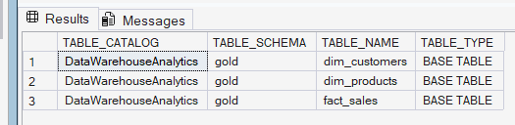

--Exploring All Columns in the Database

Query: SELECT * FROM INFORMATION_SCHEMA.COLUMNS;

Output:

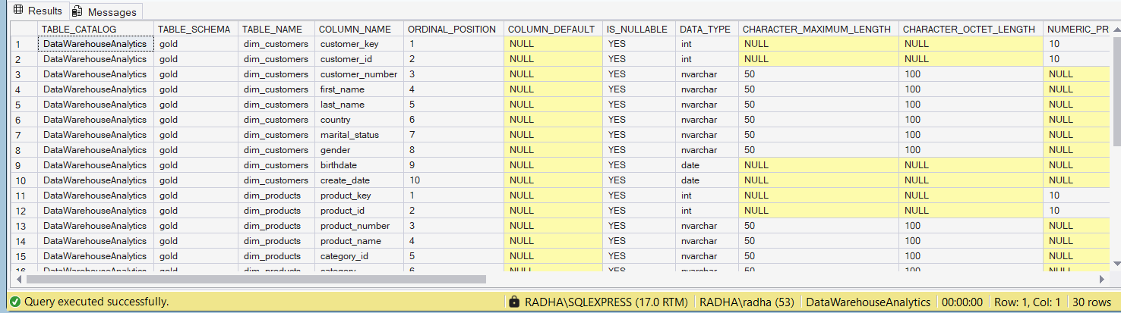

- Dimensions Exploration:

--Exploring All Countries of Customers came from

Query: SELECT DISTINCT country FROM gold.dim_customers;

Output:

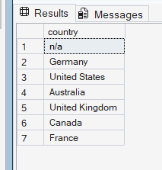

--Exploring All Product Categories, Subcategories and Product Names

Query: SELECT category, subcategory, product_name
FROM gold.dim_products
ORDER BY 1,2,3

Output:

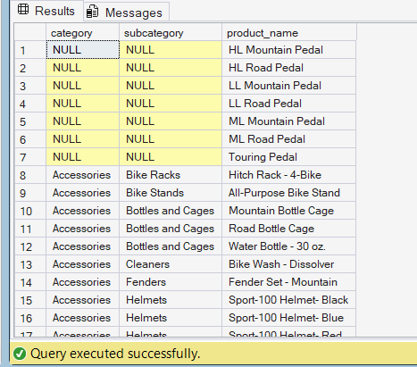

- Date Exploration:

--Find The Date of First and Last Order & How Many Years of Sales are available

Query: SELECT
MIN(order_date) AS First_Order_Date,
MAX(order_date) AS Last_Order_Date,
DATEDIFF(YEAR, MIN(order_date),MAX(order_date)) AS Order_Range_Years
FROM gold.fact_sales;

Output:

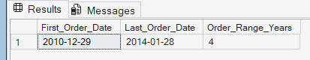

--Find The Youngest and Oldest Birthdates & Age from Customer Table

Query: SELECT
MIN(birthdate) AS Oldest_Birthdate,
DATEDIFF(YEAR, MIN(birthdate),CURRENT_DATE) AS Oldest_Age,
MAX(birthdate) AS Youngest_Birthdate,
DATEDIFF(YEAR, MAX(birthdate),CURRENT_DATE) AS Youngest_Age
FROM gold.dim_customers

Output:

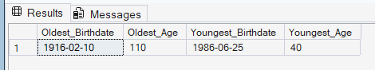

- Measures Exploration:
--Find The Total Sales

Query: SELECT SUM(sales_amount) Total_sales FROM gold.fact_sales;

Output:

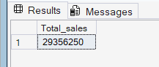

--Find How Many items are Sold

Query: SELECT SUM(quantity) Total_Quantity FROM gold.fact_sales;

Output:

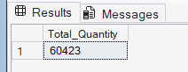

--Find The Average Selling Price

Query: SELECT AVG(price) Avg_Price FROM gold.fact_sales;

Output:

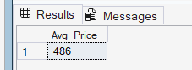

--Find The Total Number of Orders

Query: SELECT COUNT(DISTINCT order_number) Total_orders
FROM gold.fact_sales;
Output:

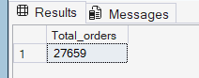

--Find The Total Number of Products

Query: SELECT COUNT(product_id) Total_Products
FROM gold.dim_products;

Output:

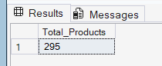

--Total Number of Customers
Query: SELECT COUNT(customer_id) Total_Customers
FROM gold.dim_customers;

Output:

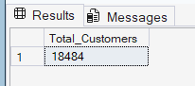

--Find The Total Number of Customers that has Placed an Order

Query:

SELECT COUNT(DISTINCT customer_id) Total_Customers
FROM gold.dim_customers c
LEFT JOIN gold.fact_sales s
ON c.customer_key=s.customer_key
WHERE S.order_number IS NOT NULL;

Output:

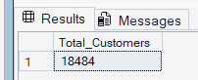

--Generate a Report That Shows all Key Metrics of The Business

Query:

SELECT 'Total Sales' AS Measure_Name, SUM(sales_amount) AS Measure_Value FROM gold.fact_sales
UNION ALL
SELECT 'Total Quantity', SUM(quantity) FROM gold.fact_sales
UNION ALL
SELECT 'Average Price', AVG(price) FROM gold.fact_sales
UNION ALL
SELECT 'Total No.Of orders',COUNT(DISTINCT order_number)
FROM gold.fact_sales
UNION ALL
SELECT 'Total No.Of Products' ,COUNT(product_id) FROM gold.dim_products
UNION ALL
SELECT 'Total No.Of Customers', COUNT(customer_id)
FROM gold.dim_customers;

Output:

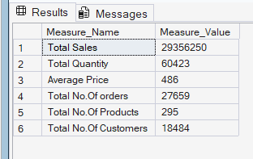

- Magnitude Analysis:
--Find The Total Customers by Country

Query:

SELECT country, COUNT(DISTINCT customer_id) 'Total Costomers'
FROM gold.dim_customers
GROUP BY country
ORDER BY 'Total Costomers' DESC

Output:

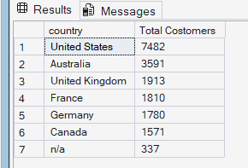
--Find Total Customers by Gender

Query:

SELECT gender, COUNT(DISTINCT customer_id) 'Total Costomers'
FROM gold.dim_customers
GROUP BY gender
ORDER BY 'Total Costomers' DESC

Output:

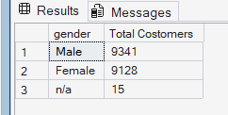

--Find The Total Products by category

Query:

SELECT category, COUNT(DISTINCT product_key) 'Total Products'
FROM gold.dim_products
GROUP BY category
ORDER BY 'Total Products' DESC
Output:
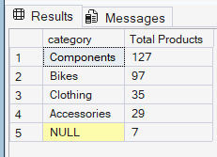
--Find The Average Cost in each Category
Query:

SELECT category, AVG(cost) 'Average Cost'
FROM gold.dim_products
GROUP BY category
ORDER BY 'Average Cost' DESC
Output:

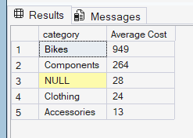
--Find The Total Revenue Generated for each Category

Query:

SELECT p.category, SUM(sales_amount) 'Total Revenue'
FROM gold.fact_sales s
LEFT JOIN gold.dim_products p ON p.product_key= s.product_key
GROUP BY category
ORDER BY 'Total Revenue' DESC
Output:

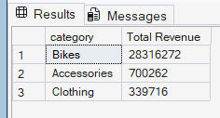

--Find The Total Revenue Generated by each Customer
Query:

SELECT
c.customer_key,
c.first_name,
c.last_name,
SUM(sales_amount) 'Total Revenue'
FROM gold.fact_sales s
LEFT JOIN gold.dim_customers c
ON c.customer_key= s.customer_key
GROUP BY
first_name,
last_name,
c.customer_key
ORDER BY 'Total Revenue' DESC

Output:
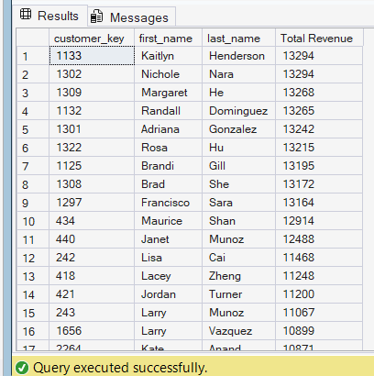
--What’s the Distribution of Sold items across countries

Query:

SELECT
c.country,
SUM(quantity) 'Total Quantity'
FROM gold.fact_sales s
LEFT JOIN gold.dim_customers c
ON c.customer_key= s.customer_key
GROUP BY country
ORDER BY 'Total Quantity' DESC
Output:

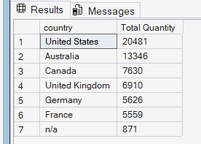

- Ranking Analysis:
--Which 5 Products Generates the Highest Revenue

Query:

SELECT TOP 5
P.product_name,
SUM(f.sales_amount) 'Total Revunue'
FROM gold.fact_sales f
LEFT JOIN gold.dim_products p
ON p.product_key=f.product_key
GROUP BY product_name
ORDER BY 'Total Revunue' DESC

Output:

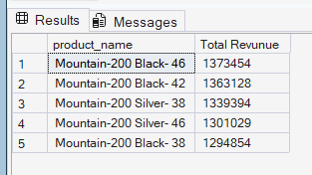

--What are the 5 Worst Performing Products in terms of Sales

Query:

SELECT TOP 5
P.product_name,
SUM(f.sales_amount) 'Total Revunue'
FROM gold.fact_sales f
LEFT JOIN gold.dim_products p
ON p.product_key=f.product_key
GROUP BY product_name
ORDER BY 'Total Revunue' ASC
Output:

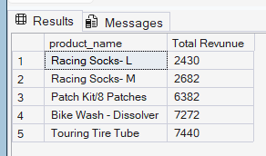
-- By Using Window Functions Which 5 Products Generates the Highest Revenue

Query:

SELECT *
FROM (
SELECT p.product_name,
SUM(Sales_amount) Total_sales,
RANK() OVER(ORDER BY SUM(sales_amount) DESC) AS rnk
FROM gold.fact_sales f
LEFT JOIN gold.dim_products p
ON p.product_key=f.product_key
GROUP BY product_name)t
WHERE rnk <=5
Output:

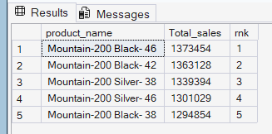

--Find The Top 10 Customers who have generated the Highest Revenue

Query:

SELECT TOP 10
C.customer_id,
c.first_name,
c.last_name,
SUM(f.sales_amount) 'Total Revenue'
FROM gold.fact_sales f
LEFT JOIN gold.dim_customers c
ON c.customer_key=f.customer_key
GROUP BY
C.customer_id,
c.first_name,
c.last_name
ORDER BY 'Total Revenue' DESC

Output:

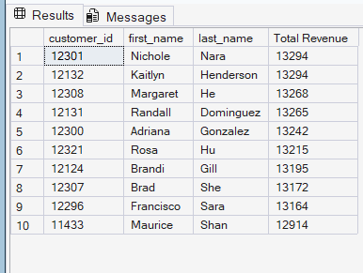

--The 3 Customers with the fewest orders Placed

Query:

SELECT TOP 3
C.customer_id,
c.first_name,
c.last_name,
SUM(quantity) AS 'Total Orders'
FROM gold.fact_sales f
LEFT JOIN gold.dim_customers c
ON c.customer_key=f.customer_key
GROUP BY
C.customer_id,
c.first_name,
c.last_name
ORDER BY 'Total Orders' ASC
Output:

